Name:
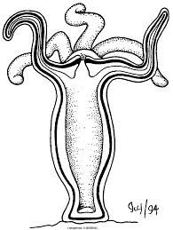Cnidarian Vocabulary List Activity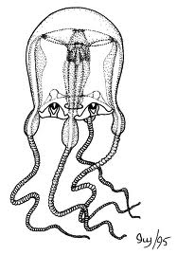
The following is a list of vocabulary terms pertaining to the structure, function, and general understanding of the organisms within the Cnidarian Phylum. For each word please provide the definition and a diagram/drawing of the word. The first word is done for you as an example.
- Mesoglea: a layer of jelly-like material between the outer and inner tissue layers of jellyfish and other Cnidarians.

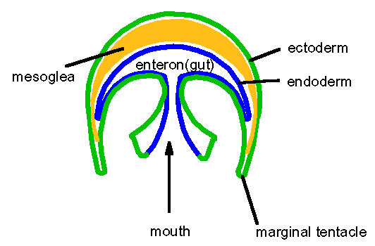
- Gastrovascular Cavity:

- Polyps:

- Medusa:

- Nematocysts:

- Cnidocytes:

