Marine Lower Invertebrate Study Guide Name:
1. What is the difference between an invertebrate and vertebrate animals?
2. Describe the evolutionary advancements seen so far between lower and upper invertebrates?
3. Compare and contrast the different types of symmetry and give an example of organisms with each type, and include what phylum the example organisms belong to.
4. Characterize and give examples of members of Phylum Porifera.
5. What Phylum is considered to be an evolutionary “dead-end” and explain why this is.
6. Characterize and give examples of members of Phylum Cnidaria.
7. Describe the life cycle of a jellyfish, differentiating between the medusa and polyp phases.
8. Describe the four classes of Phylum Cnidaria, and give examples of each.
9. Characterize and give examples of members of Phylum Platyhelminthes.
10. Discuss the ecological and economic importance of:
a) Sponges=

b) Cnidarians=

c) Flatworms=
11. Discuss the ecological and economic importance of cnidarians.
12. Explain the best way to treat a jellyfish (or other cnidarian) sting.
13. What are the major similarities and differences between the different lower invertebrate phyla (Porifera, Cnidaria, and Platyhelminthes)?
14. What impacts do invertebrates have in marine ecosystems?
15. Cnidarians contain what kind of specialized cells?

LABEL THE FOLLWING PICTURES USING THE FOLLOWING WORD BANKS:
- Sponge Anatomy [Collar Cell, Choanocyte, Amoebocyte, Spicules, Osculum, Mesohyl, Ostia]
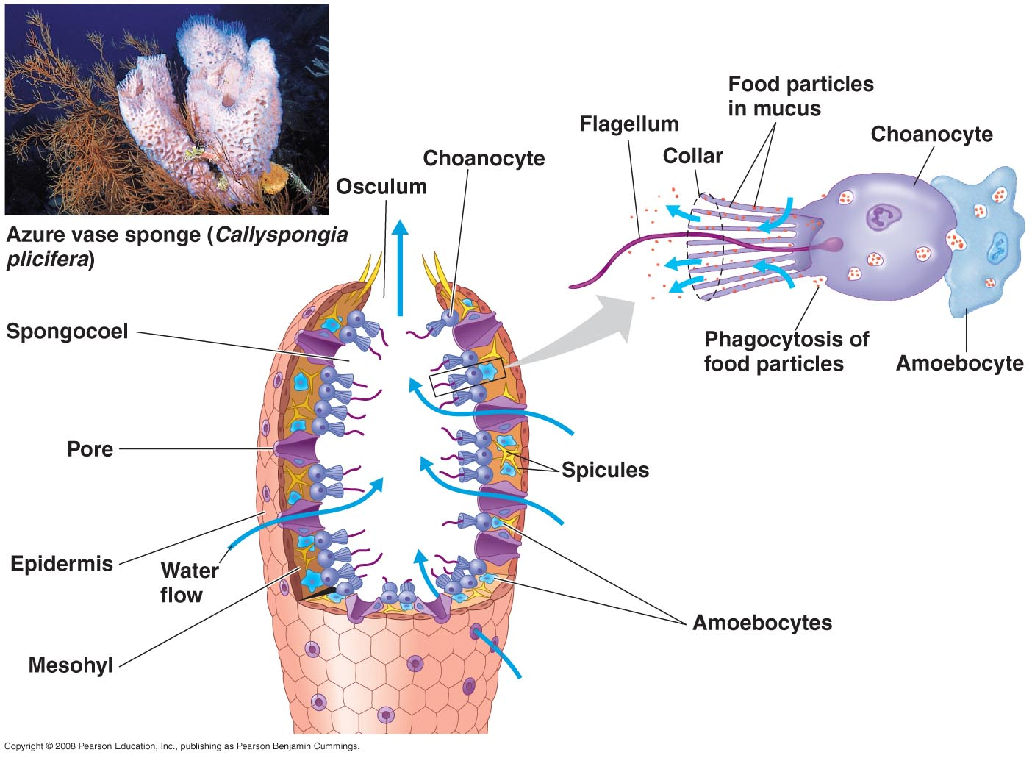
- Cnidarian Anatomy [Medusa, Tentacles, Mesoglea, Mouth/Anus, Gastrovascular cavity, Gastrodermis, Polyp, Epidermis]
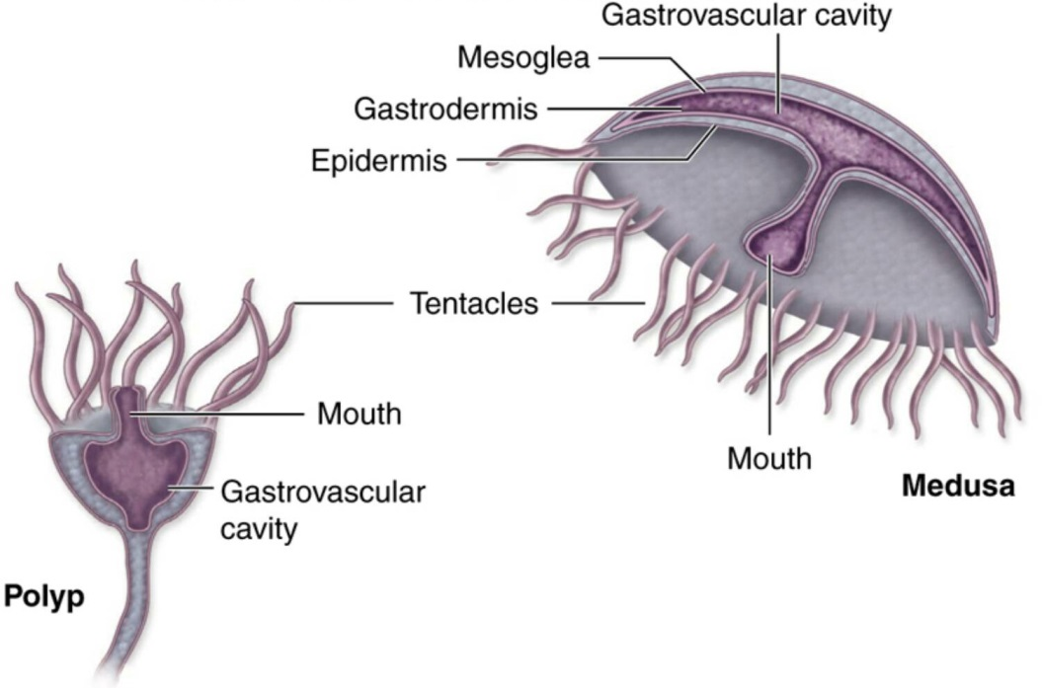

- Platyhelminthes Anatomy [Intestine, Ventrolateral Nerve, Eye, Pharynx, Brain, Mouth]
