Marine Unit 8 Study Guide: Upper Invertebrates
- In what ways are upper invertebrate phyla more advanced?
- What adaptations allow each group of upper invertebrates to thrive in their specific niche?
- What are the major similarities and differences between the different upper invertebrate phyla (Annelida, Arthropoda, Echinodermata, and Mollusca)?
- What impacts do upper invertebrates have in marine ecosystems?
- Explain what characteristics differentiate an upper invertebrate from a lower invertebrate.
- Describe evolutionary trends among the upper invertebrate phyla.
- Compare and contrast the phyla of upper invertebrates in terms of anatomy, physiology, taxonomy, and ecological requirements.
- Explain how all of these phyla function together in a marine ecosystem.
- Characterize and give examples of members of Phylum Mollusca.
- Describe the three major classes of Phylum Mollusca, and give examples of each.
- Explain why cephalopods are considered to be uniquely adapted and evolutionarily advanced.
- Characterize and give examples of members of Phylum Echinodermata.
- Discuss the ecological and economic importance of Annelids, Mollusks, Arthropods, and Echinoderms.
- In what order did the upper invertebrate phyla evolutionary advance?
For the following review questions label the following pictures with their respective phylum and their respective class or subphylum they would fall under.
- 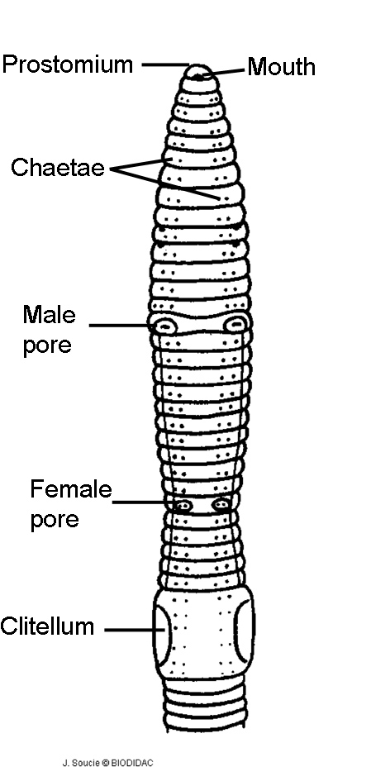 Phylum: Class/Sub-phylum:

- 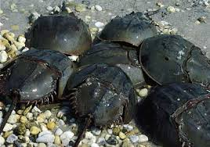 Phylum: Class/Sub-phylum:

- 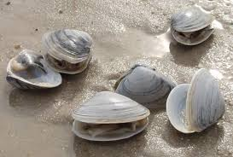Phylum: Class/Sub-phylum:

- 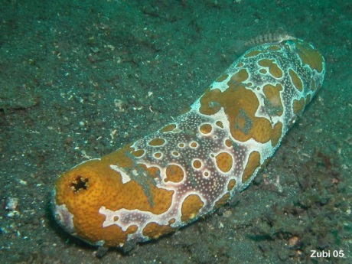Phylum: Class/Sub-phylum:

