Upper Invertebrate Anatomy Diagram Practice Side
Word Bank for both Diagrams (words can be used more than once):
Siphon, Arm, Tentacle, Eye, Mantle, Fin, Head, Uropod, Cephalothorax, Rostrum, Antennule, Antenna, Cheliped, Abdomen, Walking Legs, Swimmerets, and Telson.
Squid
Phylum:
Class:
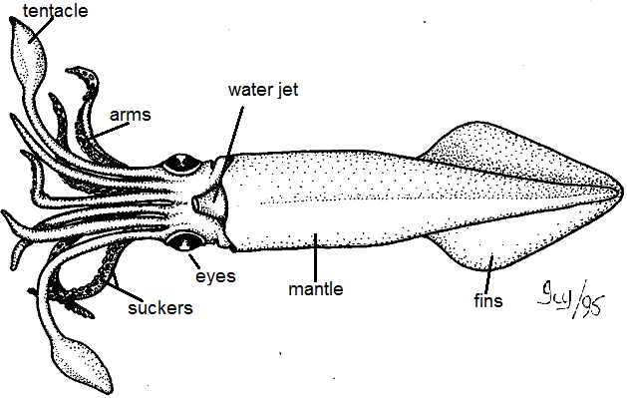
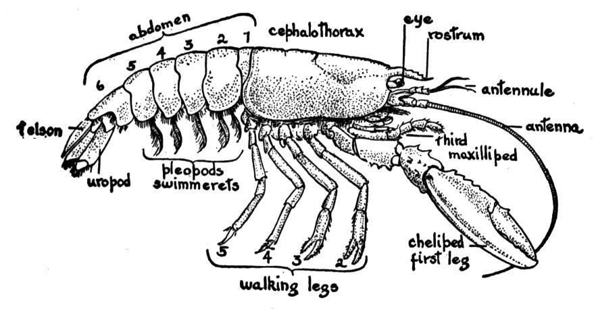
Crayfish
Phylum:
Class:
Upper Invertebrate Anatomy Diagram Answer Side

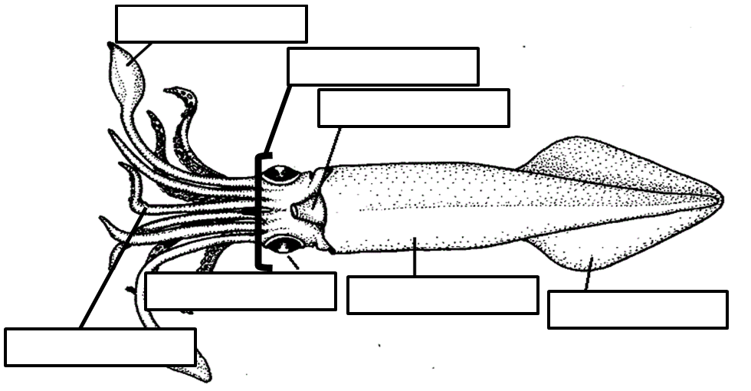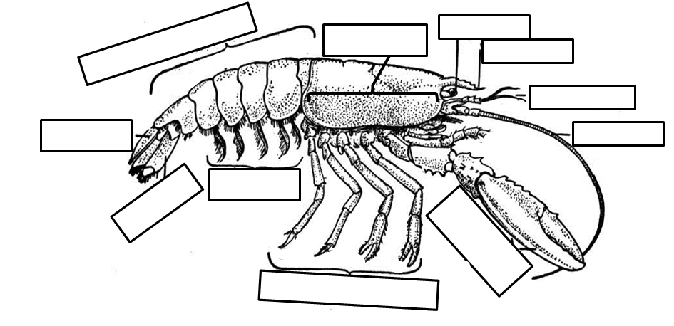
Antenna
Antennule
Rostrum
Eye
Cheliped
Swimmerets
Uropod
Telson
Abdomen
Walking Legs
Cephalothorax
Siphon
Arm
Fin
Mantle
Eye
Head
Tentacle

